USE CASES-
ARTIFICIAL INTELLIGENCE



-By
Shivam Kumar Giri

There are Thousands of Application of AI, But I feel 3 major Application of it in the present Times:
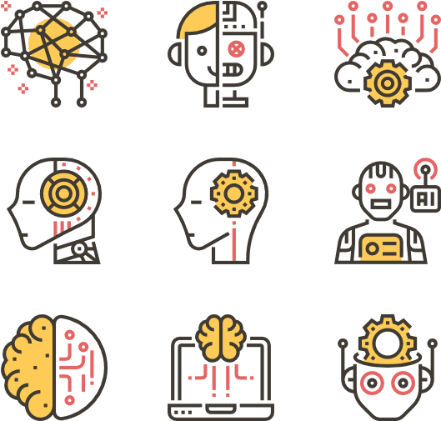
AI IN Health Technology
AI is used in following aspect of HealthTech:
- Identifying Diseases and Diagnosis
One of the chief ML applications in healthcare is the identification and diagnosis of diseases and ailments which are otherwise considered hard-to-diagnose
- Drug Discovery and Manufacturing
One of the primary clinical applications of machine learning lies in early-stage drug discovery process. This also includes R&D technologies such as next-generation sequencing and precision medicine which can help in finding alternative paths for therapy of multifactorial diseases.
- Medical Imaging Diagnosis
Machine learning and deep learning are both responsible for the breakthrough technology called Computer Vision which works on image diagnostic tools for image analysis.
- Personalized Medicine
Personalized treatments can not only be more effective by pairing individual health with predictive analytics but is also ripe are for further research and better disease assessment. But machine learning in medicine is making great strides, and works by leveraging patient medical history to help generate multiple treatment options
- Machine Learning-based Behavioral Modification
Behavioral modification is an important part of preventive medicine, and ever since the proliferation of machine learning in healthcare, countless startups are cropping up in the fields of cancer prevention and identification, patient treatment,
- Smart Health Records
The main role of machine learning in healthcare is to ease processes to save time, effort, and money and can help to maintain up-to-date health records
- Clinical Trial and Research
Applying ML-based predictive analytics to identify potential clinical trial candidates can help researchers draw a pool from a wide variety of data points, such as previous doctor visits, social media, etc.
- Crowdsourced Data Collection
Crowdsourcing is all the rage in the medical field nowadays, allowing researchers and practitioners to access a vast amount of information uploaded by people based on their own consent. This live health data has great ramifications in the way medicine will be perceived down the line.
- Better Radiotherapy
ML-based algorithms learn from the multitude of different samples available on-hand, it becomes easier to diagnose and find the variables.
- Outbreak Prediction
AI-based technologies and machine learning are today also being put to use in monitoring and predicting epidemics around the world.

AI IN Financial Technology
AI is used in following aspect of Fintech:
- Digital Financial Coach/Advisor
In finance, transactional bots can be used to offer users finance coaching/advising services. Digital assistants can be built using Natural Language Processing (NLP) that can process data in the format of human language.
- Transaction search & visualization
Chatbots can offer user-friendly transaction search, enabling users to search in their historical data for a specific transaction with a particular merchant, avoiding them the hassle of looking for these in each of their bank statements.
- Client Risk Profile
AI is an excellent tool for this as it can automate the categorization of clients depending on their risk profile, from low to high.
- Underwriting, Pricing & Credit Risk Assessment
An AI-powered model can provide an instantaneous assessment of a client’s credit risk, which then allows advisors to craft the most adapted offer.
- Automated Claims Processes
Transactional bots can transform the user experience into a more pleasant process. Enhanced with image recognition, fraud detection, and payout prediction, the entire user journey is upgraded
- Contract Analyzer
Contract analysis is a repetitive internal task in the finance industry. Managers and advisors can delegate this routine task to a machine learning model. An NLP model with layered business logic can then interpret, record, and correct contracts at high speed.
- Churn Prediction
AI can support managers in this mission by providing a prioritized list of clients who show signs of considering to cancel their policy.
- Algorithmic Trading — the most advanced ML you will never see.
The algorithm detects patterns usually difficult to spot by a human, it reacts faster than human traders, and it can execute trades automatically based on the insight derived from the data.
- Augmented research tools
In investment finance, a large portion of time is spent doing research. Sentiment analysis allows an analyst to view at a glance the tone/mood of large sets of text data such as news or financial reviews and can also provide insight into how a manager reflects their company performance.
- Valuation Models
Valuation models are usually applications for investment and banking in general. The model can quickly calculate the valuation of an asset using data points around the asset and historical examples.

AI IN MARKETING
AI is used in following aspect of Marketing:
- Sales forecasting
AI will study the data from emails, meetings, and on some occasions phone calls. AI Marketing can relate the data to the outcome of the possible sales of current and future campaigns.
- Understand customers
Through the data gathered by AI solutions, it can be easier for marketers to understand what their customer’s needs are as well as how and when they want it. Marketers can also create customer profiles to make it easier for them to segregate people with their interest in their product.
- Find the trend
AI Marketing and its ability to analyze large chunks of data can be used to detect upcoming trends by “joining in” real-time conversations or events of your users.
- Programmatic Ad Targeting
With the data from cookies of mobile applications and websites you used/visited, the AI can target specific customers that match the advertiser’s or business’s criteria. The criteria can be anything from location, age, gender, and time, among others
- Chatbots
Businesses can now set predetermined answers to the frequently asked questions of their customers or help them find and buy a product they like. Chatbots significantly reduces the time that’s needed for human intervention and response, thus, saving time and money.
- Speech Recognition
These AIs can recognize spoken words and/or convert them into the text to execute the command. Speech recognition is even used in apps such as Google Maps, Shazam, and other hands-free systems.
- Content Generation
The manual generation of content is a tedious process. Content generation, as of this writing, can only cough up simple stories such as stock updates, financial reports, sports news, and the like.
- Dynamic Pricing
This AI is often referred to as personalized pricing. It’s a pricing strategy wherein a product’s price is determined by demand and/or supply.


